**VISVESVARAYA TECHNOLOGICAL UNIVERSITY**

**“Jnana Sangama”, Belagavi - 590 018.**

** **

**MINI PROJECT REPORT**

**ON**

**“COLLEGE BUS MANAGEMENT SYSTEM”**

Subject: **DBMS LABORATORY WITH MINI PROJECT (18CSL58)**

*Submitted in partial fulfilment of the requirements for the**degree of*

##### BACHELOR OF ENGINEERING

##### IN

##### COMPUTER SCIENCE & ENGINEERING

**Submitted By**

**AKASH B.S (4AI18CS129)**

**SHRIVATHSA B.V (4AI18CS103)**

##### **Under the guidance of**

###### Mrs. Priyanka N B.E., M.Tech.

Assistant Professor, Dept of CS&E,AIT,Chikkamagaluru.



**DEPARTMENT OF COMPUTER SCIENCE AND ENGINEERING**

**ADICHUNCHANAGIRI INSTITUTE OF TECHNOLOGY**

(Affiliated to VTU, Belagavi and Approved by AICTE, New Delhi)

CHIKKAMAGALURU – 577 102, KARNATAKA, INDIA.

2020 – 2021

**ADICHUNCHANAGIRI INSTITUTE OF TECHNOLOGY**

(Affiliated to VTU, Belagavi and Approved by AICTE, New Delhi)

Chikkamagaluru- 577 102, Karnataka, India.

**Department of Computer Science and Engineering**

**CERTIFICATE**

This is to certify that the project work entitled **“COLLEGE BUS MANAGEMENT DATABASE SYSTEM”** is a bonafide work carried out by **AKASH B.S(4AI18CS129) , SHRIVATHSA B.V (4AI18CS103)** in partial fulfillment for the **DBMS Laboratory with mini project (18CSL58)** course of 5th semester Bachelor of Engineering in Computer Science and Engineering of the Visvesvaraya Technological University, Belagavi during the academic year 2020-21. It is certified that all corrections and suggestions indicated for Internal Assessment have been incorporated in the report deposited in the department library. The mini project report has been approved as it satisfies the academic requirements in respect of Mini Project Work prescribed for the said degree.

###### Dr. Pushpa Ravikumar B.E., M.Tech.,Ph.D.

Professor & Head,

Dept of CS&E,AIT,

Chikkamagaluru.

###### Mrs. Priyanka N B.E., M.Tech.

Assistant Professor,

Dept of CS&E,AIT,

Chikkamagaluru.

**Signature of the Guide Signature of the HOD**

**Name of Examiners Signature of Examiners with date**

**1.**

**2.**

###### Mrs.Priyanka.N B.E., M.Tech.

Assistant Professor, Dept of CS&E,AIT,Chikkamagaluru.

**ABSTRACT**

The College Bus Management Software Project is a desktop system aimed at students, college administration to maintain bus facility. The system takes student information as an input source and attempts to maintain bus services. It allows flexibility during these processes.

The system generates exhaustive reports related to the Bus Management i.e. Fees, Student ,Stops, rout no. & bus stop. The reports highlight various bus services and features of the bus, which can be subjected to improvements especially for the college administration to improve the bus transport system.

The system requires a comparatively small amount of resources such as memory, input/output devices, and disk space.

The system overall keeps approach in highlighting key features of the bus services

In our proposed system we have the provision for adding the details of the

students. Another advantage of the system is that it is very easy to edit the

details of the student and delete a student when it found unnecessary. Here is

facility of find root, direction, individual profile facility is also provided. Online

updating and changes is possible

**ACKNOWLEDGEMENTS**

We express our humble Pranamas to his holiness **Parama Poojya Jagadguru Padmabushana Sri Sri Sri Dr. Balagangadharanatha MahaSwamiji** and **Parama Poojya Jagadguru** **Sri** **Sri Sri Dr. Nirmalanandanatha MahaSwamiji** and also to **Sri Sri Gunanatha Swamiji** Sringeri Branch Chikkamagaluru who have showered their blessings on us for framing our career successfully.

We are deeply indebted to our honorable Principal **Dr. C. T. JAYADEV** for creating the right kind of care.

We express our deepest gratitude to **Dr. Pushpa Ravikumar**, Professor & Head, Department of Computer Science & Engineering, AIT, Chikkamagaluru for her valuable guidance, suggestions and constant encouragement without which success of our project work would have been difficult.

We are thankful to our guide **Mrs. Priyanka N**, Assistant Professor, Department of Computer Science & Engineering, AIT, Chikkamagaluru for her inspiration and lively correspondence right from the beginning of our project work till its completion.

We would like to thank our beloved parents for their support, encouragement and blessings.

And last but not the least, we would be very pleased to express our heartfelt thanks to all teaching and non-teaching staff of CS&E department and our friends who have rendered their help, motivation and support.

**AKASH B.S (4AI18CS129)**

**SHRIVATHSA B.V (4AI18CS103)**

**Table of Contents**

Abstract i

Acknowledgements ii

Table of Content iii

List of Figures iv

List of Tables v

**Chapters**

**1. INTRODUCTION**

1.1 Introduction to College Bus Management database system

**2. SOFTWARE and HARDWARE SPECIFICATION**

2.1 Overview

2.2 Specific Requirements

2.2.1 Software Requirements 2.2.2 Hardware Requirements

**3.** **COLLEGE BUS MANAGEMENT DATABASE DESIGN**

3.1 E-R Diagram

3.2 Relational Schema

**4. IMPLEMENTATIONS**

4.1 RDBMS Tables and their Description

4.2 MySQL Query

4.3 Connecting to MySQL using php code

**5. RESULTS CONCLUSION AND FUTURE ENHANCEMENT**

6.1 Conclusion

6.2 Future Enhancement

**REFERENCES**

**List of Figures**

Figure No. Figure Name

Figure 1.1: Architecture of the ISRO Database management system

Figure 3.1: E-R diagram of ISRO Satellite database

Figure 3.2: ISRO Satellites Relational Schema Figure 5.1:Snapshot display Home page for college bus anagement System

Figure 5.2: This Snapshot displays the admin login page

Figure 5.3: : Snapshot of insert student details to table.

Figure 5.4 : Snapshot of Delete student details in table.

Figure 5.5: Snapshot of update of fee in table

Figure 5.6: Snapshot of gallery

Figure 5.7: Snapshot of retrieving student details

Figure 5.8: Snapshot of retrieving fee details

Figure 5.9: Snapshot of retrieving Staff details

Figure 5.10: : Snapshot of retrieving Driver details

**List of Tables**

**Table No. Table Name**

Table 1: Admin Details

Table 2: Student Details

Table 3: Staff Details

Table 4: Driver Details

Table 5: Fee structure

**CHAPTER 1**

**INTRODUCTION**

* 1. **Introduction to College Bus Management database system**

In the existing system Colleges have to manually maintain information regarding College busses and routes. Information relating to student passengers and driver have to be maintained separately.

Need for System  
    Provide a simpler method to store and access information related to buses ,staff and students.  
    Provide a simple interface which will be easily used without much training.  
    Reduce paperwork and make all related information accessible easily.  
  
 Scope of Work  
The Bus Management System is being developed to provide a tool for the different colleges to easily maintain the college bus information..  
At the start of the project setup, it provides an interactive part to store information about buses; different routs of buses, student information,and driver infoetc.  
  
During the period of finalizing the idea of the system, the primary goal was to design the system i.e those who don’t know how to handle the software. As designing work began and things started taking shape, the system got developed to a stage where it would be used by entry level.

**Chapter 2**

**SOFTWARE AND HARDWARE SPECIFICATION**

The College Bus Management database makes use of various software and hardware for its design. It makes use of present technologies and tools for making it easier for better performance and also to improve the efficiency of the overall system.

**2.1 OVERVIEW**

 This system is to reduce the consumption of time during maintaining the records of college Transport management. Separate divisions are provide to maintain the records of Student, faculty, Roots, diversion, etc. Faster execution Easy operation for the operator of the System. Simple database is maintained , In other words the objective of the present college Transport management software are user friendly and attractive, it takes very less time for the operator to get use-to with the system.maintaining the records

 Our software will overcome all these “Safe, efficient, reliable, and sustainable movement of persons and goods over time and space”.In our proposed system we have the provision for adding the details of the students. Another advantage of the system is that it is very easy to edit the

details of the student and delete a student when it found unnecessary. Here is

facility of find root, direction, individual profile facility is also provided. Online

updating and changes is possible.

By developing the system, we can attain the following facilities:

* Easy to handle and feasible.
* Easy to operate.
* Cost reduction.
* Fast and convenient

**2.2 SPECIFIC REQUIREMENT**

Any system design requires tools and technologies for its easy and efficient performance. Below are the specification of software and hardware that has been used for the design and implementation of theCollege Bus Management database system.

**2.2.1 SOFTWARE REQUIREMENTS**

Software is required to store the data about the tourism management and MySQL is used to serve this purpose. The details are divided into 5 tables and stored. They are mapped so that the data can be easy retrieved through connectivity. The queries, procedure and the triggers are used for performing various actions on the database.

For the front end Adobe Dream viewer is used which helps to create a web pages as per the requirement of the project. The front end is connected to the database with the help of the xampp server. The queries are written as per the buttons and links created in the front end and this result in easy retrieval of the data from the database system.

* Operating System : Window 10
* Front End :Adobe Dream viewer 2020
* Programming Language : Html and css
* Back end :My SQL
* Connection Language :php

**2.2.2 HARDWARE REQUIREMENTS**

Similar to that of software requirements there are some hardware requirements that is essential for the operation of the College Bus Management database system. A processor of core i5 is used for this system development. Memory is needed for storage in the back end as well as for the execution at the front end.

* Processor :i5 processor or higher version
* Ram :1 GB or more
* Hard Disk Free Space :4GB

**CHAPTER 3**

**COLLEGE BUS MANAGEMENT DATABASE DESIGN**

**3.1 E-R Diagram:**

An **entity-relationship diagram** (**ERD**) is a data modelling technique that graphically illustrates an information system's entities and the relationships between those entities.

An entity-relationship model (ER model) describes inter-related things of interest in a specific domain of knowledge. An ER model is composed of entity types (which classify the things of interest) and specifies relationships that can exist between instances of those entity types.

An **entity-relationship diagram (ERD)** is crucial to creating a good database design. It is used as a high-level logical data model, which is useful in developing a conceptual design for databases. An entity is a real-world item or concept that exists on its own. Entities are equivalent to database tables in a relational database, with each row of the table representing an instance of that entity.

An attribute of an entity is a particular property that describes the entity.A relationship is the association that describes the interaction between entities. Cardinality, in the context of ERD, is the number of instances of one entity that can, or must, be associated with each instance of another entity. In general, there may be one-to-one, one-to-many, or many-to-many relationships.

Figure 3.1 shows the sample ER diagram which consists of five entities

manages

Manages

Fee

Driver

Staff

Student

Admin

**3.2 Relational Schema:**

The relational schema gives the relation of one entity with another as well as the information about the key constraints. The below figure is sample relational schema diagram in which the attributes that are underlined are the primary key and the arrow line is used to represent the mapping.

The figure 3.2 shows the schema diagram for the Tourism Management database system. As, mentioned previously the database system consists of 5 entities and 2 relations. The names that are placed inside the rectangular boxes specify the attributes. The line with arrows is indicating the mapping between the relations.

**ADMIN:**

Password

Username

**Student:**

Stop

Route

Branch

Phno

Name

id

**Staff:**

Stop

Route

Branch

Phno

Name

id

**Driver:**

Route

Busno

Phno

Name

id

**Fees:**

Last date

Tpayment

Spayment

Fpayment

id

**Chapter 4**

**IMPLEMENTATION**

**4.1 RDBMS tables and their description**

Below table shows the list of tables used in implementation of the College Bus database management system.

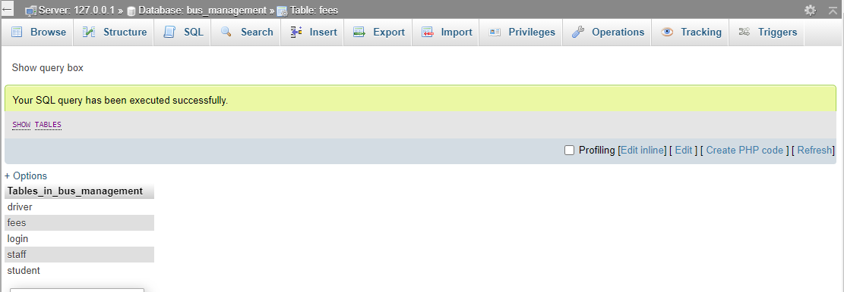

figure 4.1:list of tables in College bus database management system

**4.1.1 Students:**

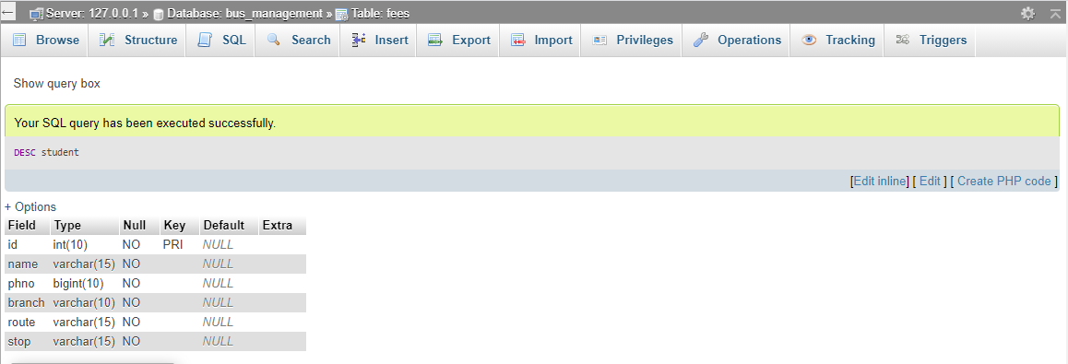

Figure 4.2: Students details

**4.1.2 Staff:**

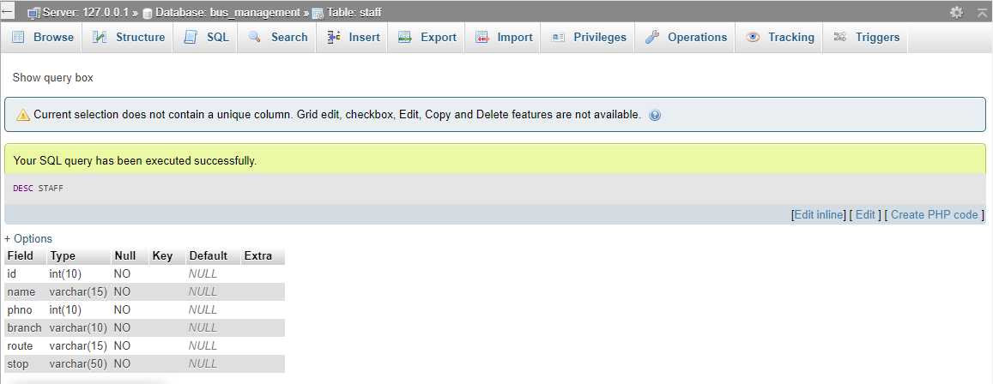

Figure 4.3: Staff details

**4.1.3 Driver :**

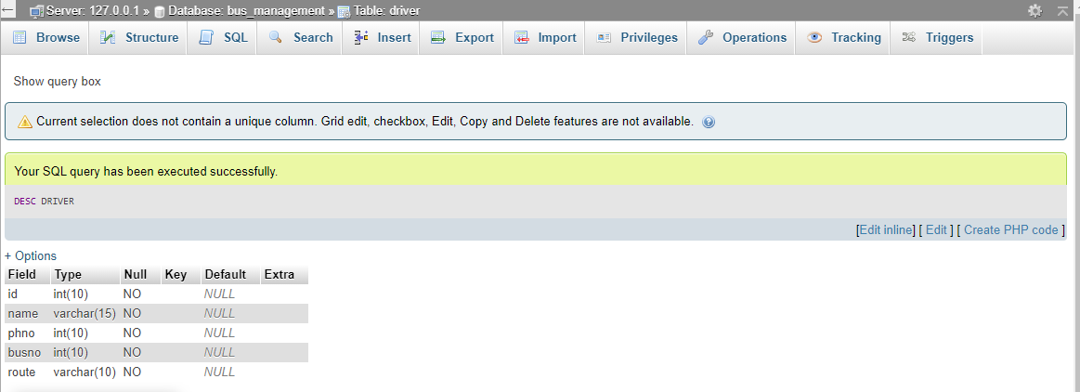

Figure 4.4: Drivers details

**4.1.4 Fees:**

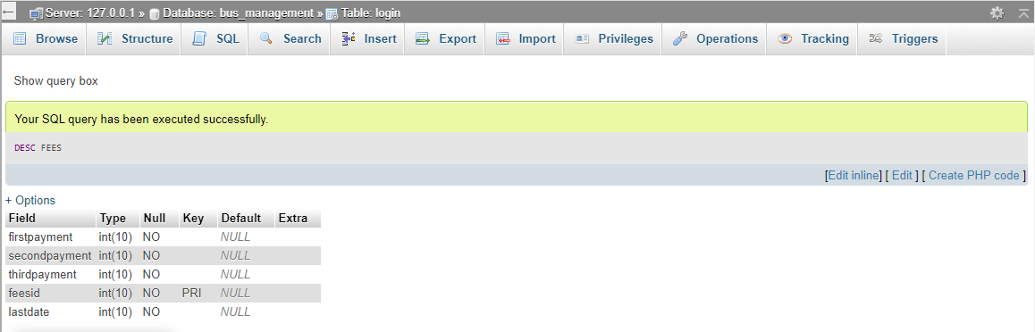

Figure 4.5: Fees details

**4.1.5 Login:**

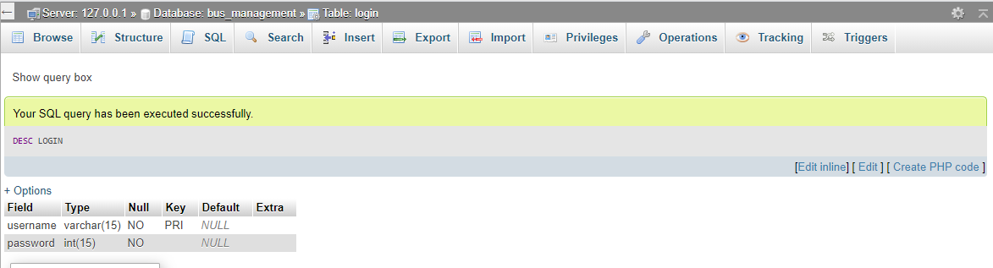

Figure 4.6: login details

**4.2 MySQL Query**

1. **Insert the details of the student to database**

INSERT INTO `student`(`id`, `name`, `phno`, `branch`, `route`, `stop`) VALUES ([value-1],[value-2],[value-3],[value-4],[value-5],[value-6])

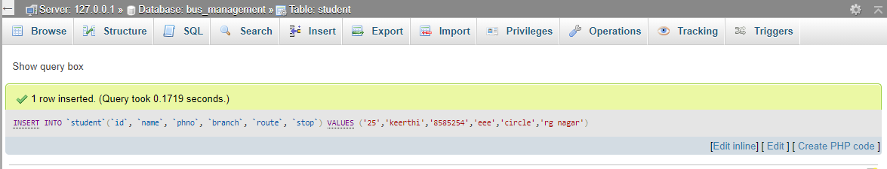

Figure 4.6: Query to insert the details of students

1. **Delete the details of the student in Database.**

DELETE FROM `student` WHERE id=2

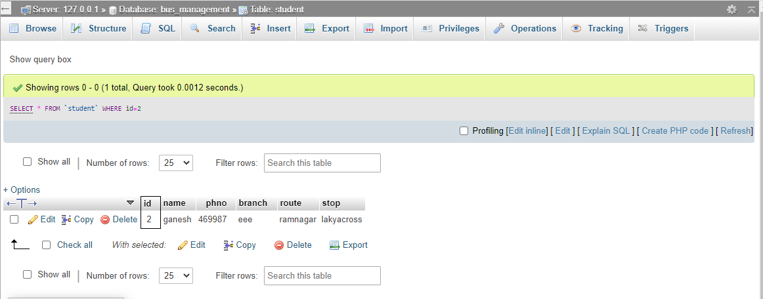

Figure 4.7: Query to delete the details of the student

1. **Select command to retrieve the data from admin**

SELECT * FROM `student` WHERE 1

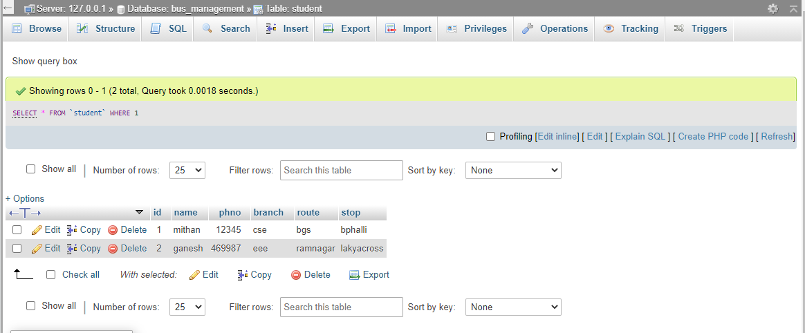

Figure 4.8: Query to Retrieve the details of admin to get login

1. **update command to update the fee**

UPDATE fees SET firstpayment='$firstpayment',secondpayment='$secondpayment',thirdpayment='$thirdpayment',lastdate='$lastdate' WHERE feesid='$feeid'";

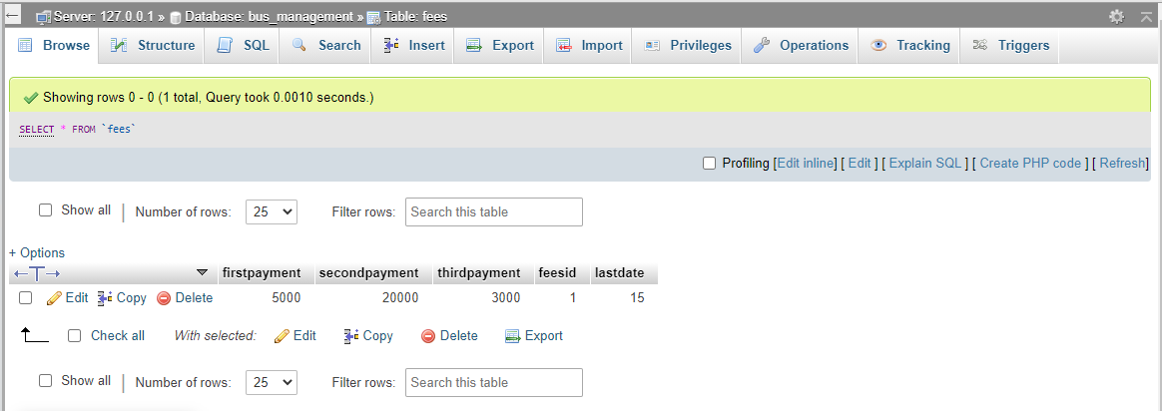

Figure 4.9: Query to update the fees in database

1. **Alter table command**

ALTER TABLE staff ADD busno varchar(20) NOT NULL

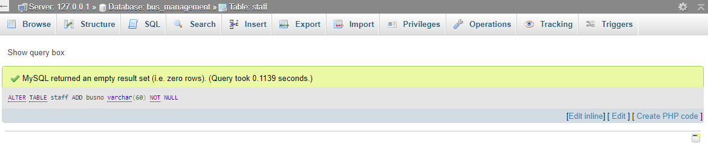

FIG 4.10: Query to alter the table

**4.3 Connecting to MySQL using PHP code**

<?php

$server="localhost";

$user="root";

$pwd="";

$db="bus_management";

$conn=mysqli_connect($server,$user,$pwd,$db);

if (!$conn)

{

die('connection unsuccessful:'.mysqli_error());

}

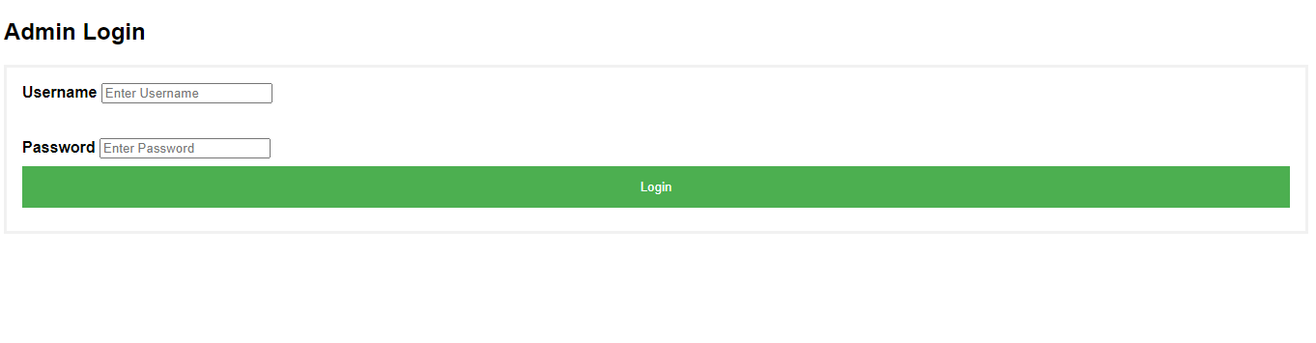fig 4.11: connecting my sql using PHP code

**CHAPTER 5**

**RESULTS**

**5.1 OUTPUT 1**

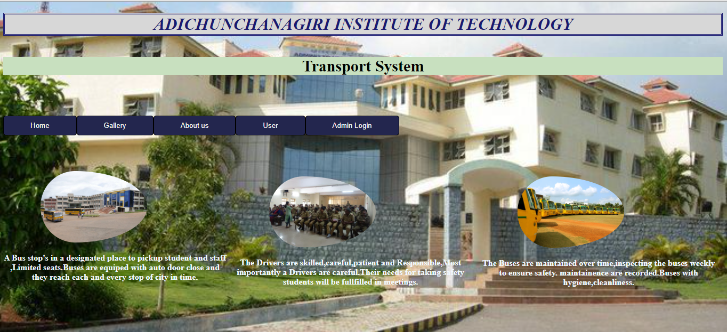

**Snapshot 5.1: Snapshot displays Home page for the College Bus management system.**

**5.2 OUTPUT 2**

 **Snapshot 5.2: This Snapshot displays the admin login page**

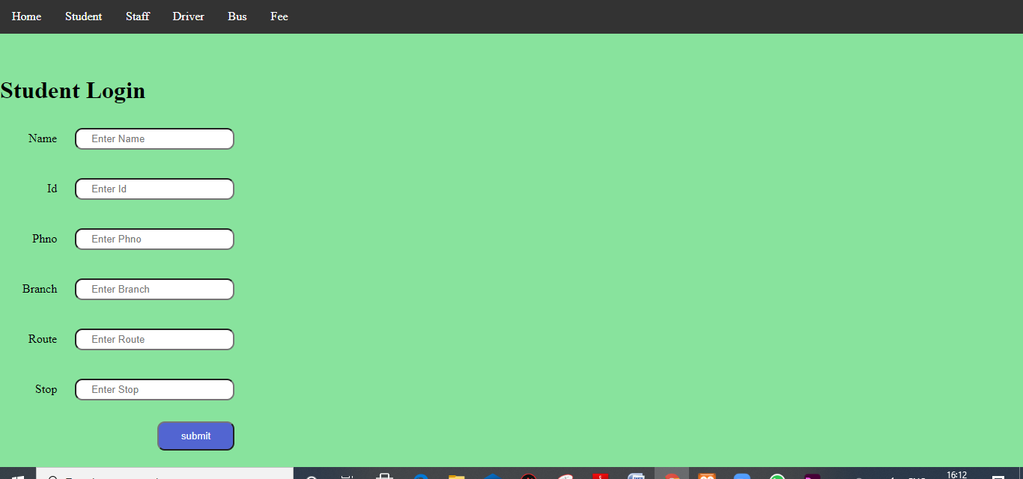**5.3 OUTPUT 3**

**Snapshot 5.3 : Snapshot of insert student details to table.**

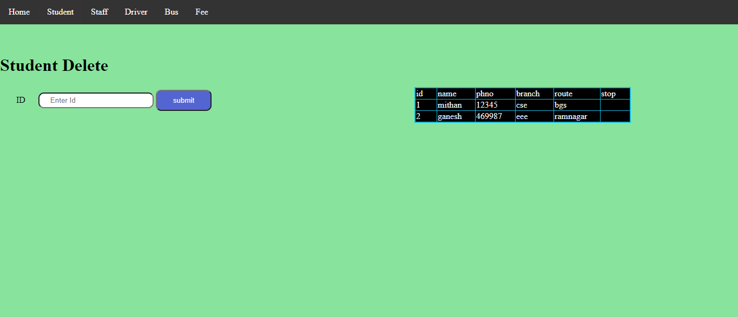**5.4 OUTPUT 4**

**Snapshot 5.4 : Snapshot of Delete student details in table.**

**5.5 OUTPUT 5**

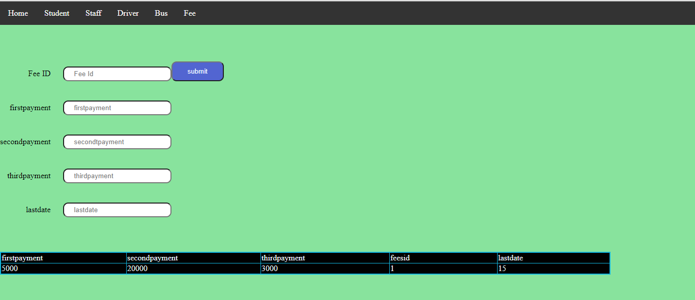

**Snapshot 5.4 : Snapshot of update of fee in table**

**5.6 OUTPUT 6**

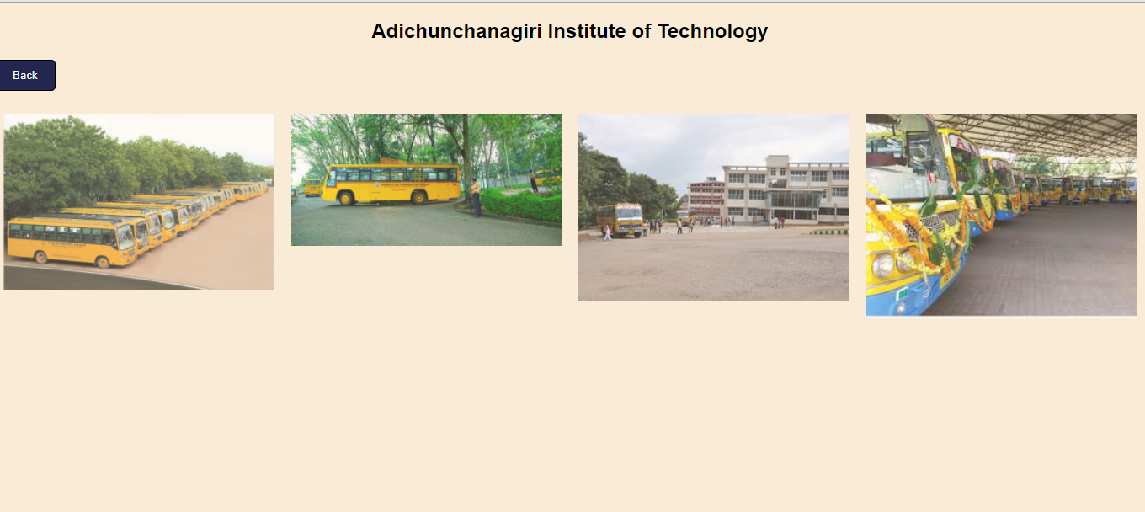

**Snapshot 5.6 : Snapshot of gallery**

**5.7 OUTPUT 7**

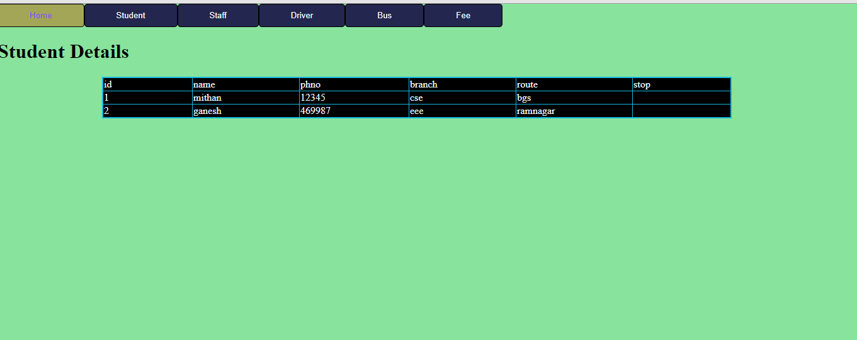

**Snapshot 5.6: Snapshot of retrieving student details**

**5.8 OUTPUT 8**

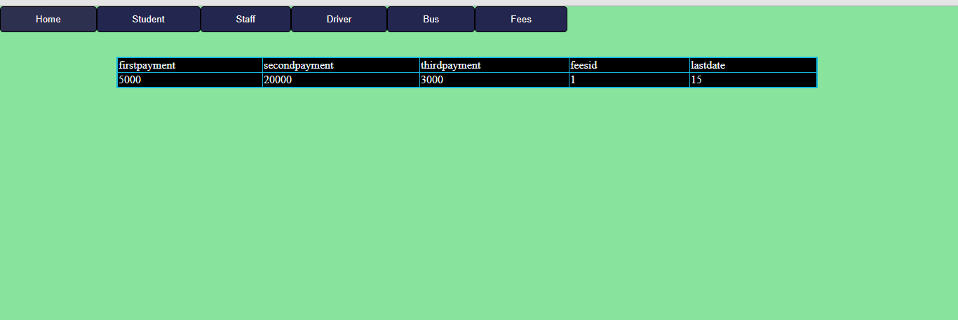

**Snapshot 5.8: Snapshot of retrieving fee details**

**5.9 OUTPUT 9**

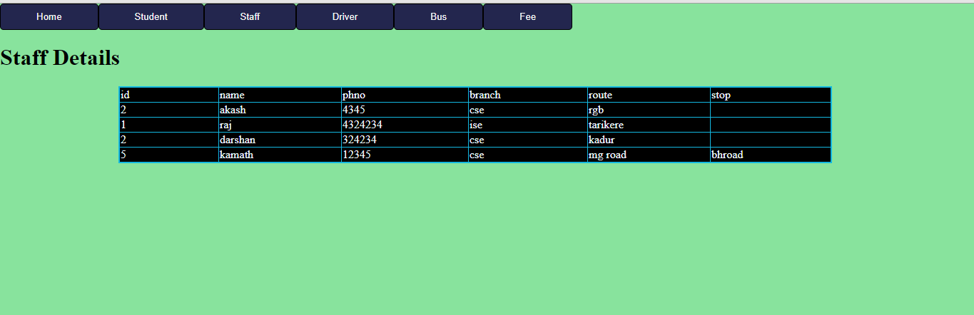

**Snapshot 5.9: Snapshot of retrieving Staff details**

**5.9\10 OUTPUT 10**

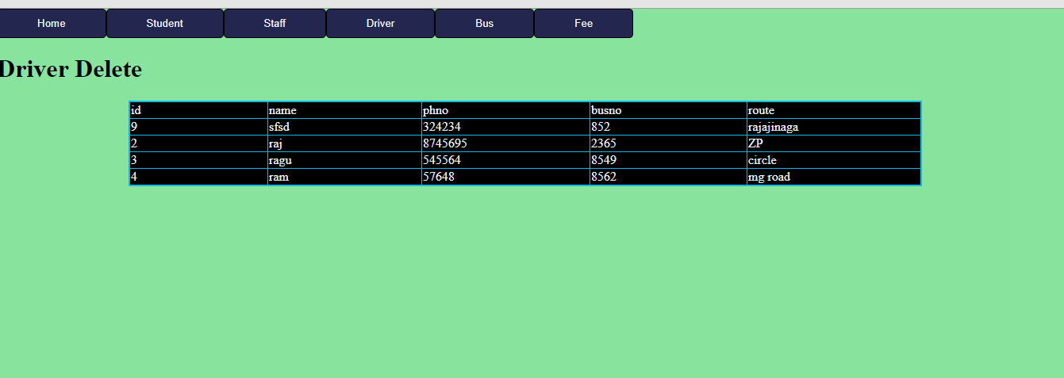

**Snapshot 5.10: Snapshot of retrieving Driver details**

**Chapter 6**

**CONCLUSION AND FUTURE ENHANCEMENT**

**6.1 Conclusion**

This project gave us the idea about, how large data are stored inside a database and organised so that it can be retrieved easily and in a more efficient way. It also helped us in learning to create application using php code and connecting the back end with the front end using the PHP code, so that any actions that are performed in the front end are reflected in the back end and also any modifications made at the back end can also be seen in the front end. It also gave us complete idea about how the queries retrieve data from multiple tables and the working of structured procedure and the triggers. This project is used to maintain the College Bus Management System efficiently.

**6.2 Future enhancement**

In future this system can be extended to the desired level so that it can adapt to the changing technology and enhance its performance. The latest data can also be included into the database so that the future retrieval keeps all the necessary data that has been updated. The system can be provided with any sort of queries to perform the required actions with the help of the schema. It also performs some computations that can be altered or modified as per the latest requirements.

**REFERENCES**

1. Fundamentals of Database Systems, Ramez Elmasri and Shamkant B. Navathe, 7th Edition, 2017,

Pearson.

2. Database management systems, Ramakrishnan, and Gehrke, 3rd Edition, 2014, McGraw Hill

3. Silberschatz Korth and Sudharshan, Database System Concepts, 6th Edition, Mc-GrawHill, 2013.

4. Coronel, Morris, and Rob, Database Principles Fundamentals of Design, Implementation and

Management, Cengage Learning 2012.